Practical 4

**Aim :** Weather Analysis application using python and mapReduce

Step 1 : Creating a text file with all the weather data in a folder called **weather**

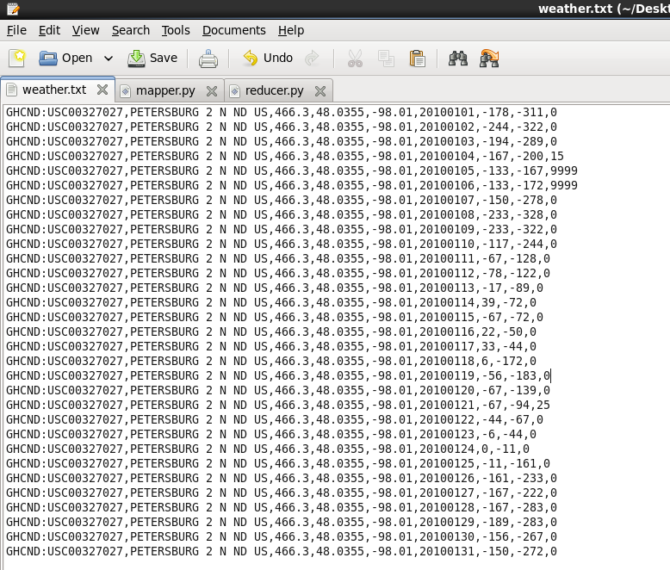

**Step 2 :** Create a mapper function in a python file called mapper.py.

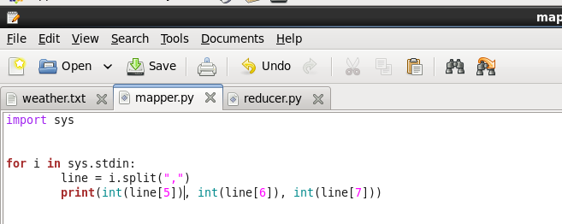

**Step 3 :** Creating a reducer function in the same folder weather

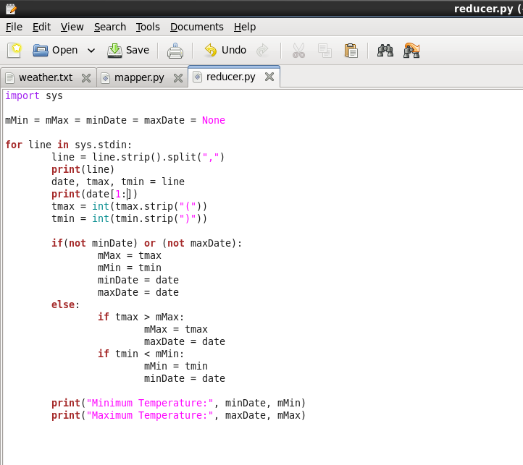

**Step 4 :** Running the mapper function with the weather text file to check the output

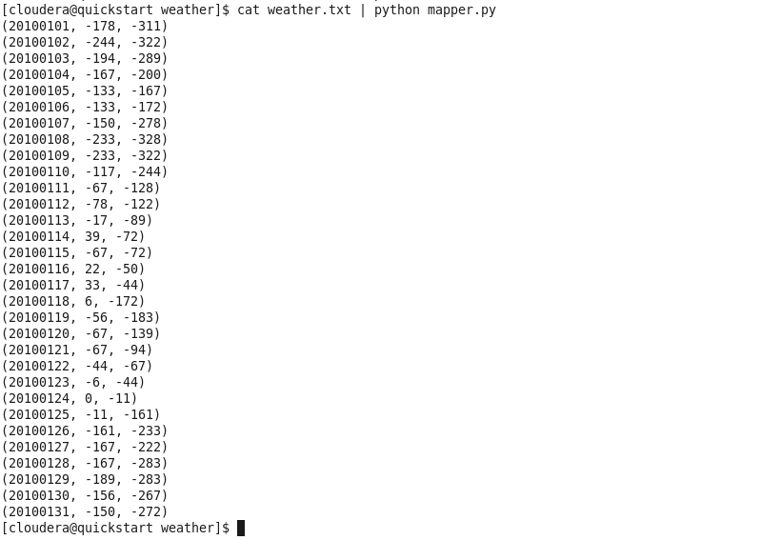

**Step 5 :** The mapper function will put these values in the stream which will be used by the reducer function and give the output

